**CHAPTER 1**

**INTRODUCTION**

* 1. **Introduction**

The status of women in India has gone through many great changes over the past few millennia. This system focuses on a security system that is designed solely to serve the purpose of providing security to women so that they never feel helpless while facing such social challenges. The system consists of various modules such as GSM shield (SIM), arduino, RTC and Heartbeat sensors.

Delhi Nirbhaya case that triggered the whole nation was the greatest motivation for this system. It was high time we women needed a change.We are all aware of importance of women's safety, but we must realize that they should be properly protected. Women’s are not as physically strong as men, in an emergency situation a helping hand would be a relief for them. The best way to minimize your chances of becoming a victim of violent crime (robbery, sexual, rape, domestic violence) is to identify and call on resources to help you out of dangerous situations. Whether you're in immediate trouble or get separated from friends during a night out and don't know how to get home, having these apps on your phone can reduce your risk and bring assistance when you need it.

This all system consists of a watch, GPS, GSM, ardiuno and heart beat sensor. The working of overall system is irregular heart beat is measure at the wrist by using heart beat sensor, when heart beat is increased then GPS and GSM is activated and it send the message alert to a emergency contacts .

* **Two Ways to Measure a Heartbeat**
* **Manual Way**: Heart beat can be checked manually by checking one’s pulses at two locations- wrist (the **radial pulse**) and the neck (**carotid pulse**). The procedure is to place the two fingers (index and middle finger) on the wrist and count the number of pulses for 30 seconds and then multiplying that number by 2 to get the heart beat rate. However pressure should be applied minimum and also fingers should be moved up and down till the pulse is felt
* **By Using a sensor**: Heart Beat can be measured based on optical power variation as light is scattered or absorbed during its path through the blood as the heart beat changes.

**1.2 Objectives**

* Security is the condition of being protected against danger or loss. In the general sense, security is a concept similar to safety. The nuance between the two is an added emphasis on being protected from dangers that originate from outside. Individuals or actions that encroach upon the condition of protection are responsible for the breach of security.
* A simple project involving Arduino UNO, OLED Display, RTC and Heartbeat Sensor Module is designed here which can calculate the heart beat rate of a person.
* The system can be interconnected with the alert the neighbors. This detection and messaging system is composed of a GPS receiver, Microcontroller and a GSM Modem. GPS Receiver gets the location information from satellites in the form of latitude and longitude.
* The main objectives of the overall system is the to secure the women by using the biomedical sensor and this sensor is mounted on watch containing a emergency switch and when press the switch as per our need then the system is an active mode to measure the Arrythmi (irregular heart beat) when it increase then it send to the GPS and GSM and it track the location.

**CHAPTER 2**

**LITERATURE REVIEW**

D. G. Monisha, M. Monisha, G. Pavithra, and R. Subhashini have proposed a voice keyword recognizing app to recognize the user and activate the app functionality even when the mobile keypad locked. The GPS module tracks the longitude and latitude to trace an exact location of a user and sends the pre-stored emergency message including location to the registered contact numbers. The Audio Recording module starts the recording of the conversation for five minutes and stored as evidences. The message goes in queue if network problem and send when network gets available. A notification is generated for successful deliver message. Also user can select contact through voice based contact list and make a call. Note: The spoken keyword converted into a text to compare with the registered keyword. [1]

Dr. Sridhar Mandapati, Sravya Pamidi, Sriharitha Ambati have concluded an emergency response situation recognizing app called as IPROB to provide women safety even in the situation like terrorist attacks or natural disaster, by just shaking the mobile above the predefined threshold value automatically activate the system. It starts capturing the surrounding voice to test and confirm the unsafe IPROB situation where it raised the notification and user fail to respond in predefine time then the message alert sends to the register contacts. If the mobile profile at the receiver is in silent mode then convert it into the General profile to give the voice notification as ꞌꞌyour child is in trouble plz help...plz help …‖ꞌꞌ continuously like a ring tone, until they stop it. If a register contact confirms a PROB then appropriate emergency services like ambulance, fire brigade are alerted. If a register contact responds with an audible notification, then it automatically connects and enables the speakerphone at the victim side. An integrated tri-axial accelerometer used to evaluate the unique movements that a phone experiences as threshold. [2]

Deepak Sharma, Abhijit Paradkar have suggested that android app to provide security different situations as follows. The module provide security to Women at Emergency Situations propose a Save Our Souls (SOS) app to provides the security on a single click of SOS button for the women travelling at night or alone. No need to unlock the screen, instead by just pressing the power button it directly triggers the application to run at the background, to send the emergency message including the location in the form of latitude and longitude to the registered contacts. [3]

Prof. R.A. Jain, Aditya Patil, Prasenjeet Nikam, Shubham More, Saurabh Totewar,”, proposed an app, in which a single click of SOS sends a message containing the location and/ or audio- video call to the guardian number. At receiver touch the location URL in the message to view it in the Google Map. It also provides different help tools like First-Aid help, Fake Call Help and video call. The First-Aid help tool provides the help on various health issue problems occurred at an accidental or emergency situation during the night time. First aid help for various problems are as: unconscious and not breathing, choking, bleeding heavily, burns, heart attack, diabetes etc. The Fake call help to escape from the meetings- parties at a time when women start feeling uncomfortable and think that, ―if someone calls me then I can leave this place‖. Fake call rings tone same as that of normal incoming call ring and once call accepted it stop ringing. It also supports Fake Hang Up option. The guardian contacts are by-default for this app, but it able to search the cops, firemen, hospitals contacts nearby to your location. It also sends the audio-video recording via Email-Gmail of emergency situation taken by the user where user unable to speak or tell the circumstances. [4]

Swapnil N. Gadhave, Saloni D. Kale, Sonali N. Shinde. proposed an automated highly reliable women security device which consist of the advanced sensors embedded in a wearable dresses. It consist of advanced sensors, GSM and ATMEGA8 microcontroller with ARDUINO tool which keep user under observation at all the time. It monitors the heart beatrate, temperature and vibration in body through sensors to check for uneasy situation. In such situation it will activate the GPS module to track the location and wireless camera to capture the images that get send to the control room of the receiver through GSM modules to take necessary actions. At the same time processor activate the mice unit with amplifier which strengthens the voice of the women to screams or shout above the threshold limit. [5]

**CHAPTER 3**

**PROBLEM DEFINITION**

Women’s safety is a very important issue due to rising crimes against women these days. As we all know that India is a most famous country all over the world for its great tradition and culture where women are given most respected place in the society from the ancient time. It is the country where women are considered as safer and most respected. Women are given the place of Goddess Lakshmi in the Indian society. Indian women are found working in all fields like aeronautics, space, politics, banks, schools, sports, businesses, army, police, and many more. We cannot say that this country has no any women concern however we cannot ignore positive points for women in India. It was all that what we see from our open eyes however if we see behind the curtain we will found all the crimes against women at home, offices, streets, etc. By seeing last few crimes against women in India such as rape cases, acid attacks, etc, the safety of women has been in doubt. Safety of women matters a lot whether at home, outside the home or working place. According to the survey in India 53% of working women are not feeling safe - Women is working in night shift (Bangalore56%, Chennai-28%, Hyderabad-35%, Mumbai-26%). Overall 86% of working women in India, women facing hurdles are high in Delhi, Mumbai, Hyderabad, Kolkata and Pune comparatively to other places. Women Safety Device can play a major role by providing women a safe environment in all situations for example (detecting hidden camera, physically threatened, harassed, robbery, stalked). Implementing real time application and a device, we can solve the problems to an extent. With further research and innovation, this project can be used as a small wearable device like watch, pendent etc.

**CHAPTER 4**

**METHODOLOGY**

* **Arduino Board**
* **Heart beat Sensor**
* **OLED Display**
* **RTC**
* **7805 Voltage Regulator IC**
* **4700 uF/50V Electrolytic Capacitor**
* **GSM Module**

**COMPONENTS DESCRIPTION**

* 1. **Arduino Board:-**

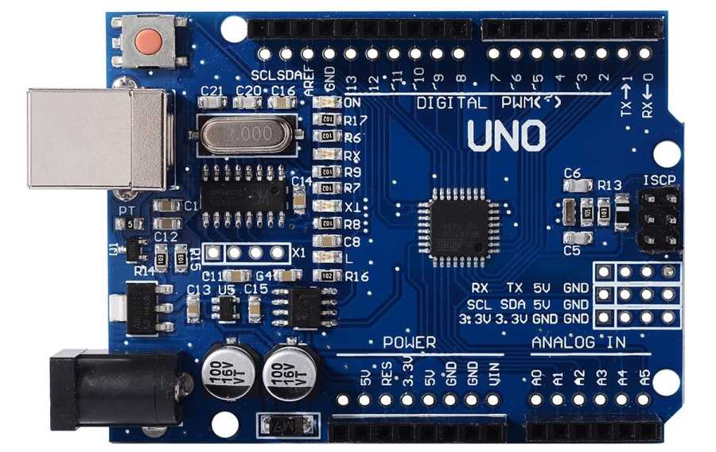

**Fig3.1 Arduino board**

Arduino is an open source computer hardware and software company, project, and user community that designs and manufactures single-board microcontrollers and microcontroller kits for building digital devices and interactive objects that can sense and control objects in the physical and digital world. The project's products are distributed as open-source hardware and software, which are licensed under the GNU Lesser General Public License (LGPL) or the GNU General Public License (GPL), permitting the manufacture of Arduino boards and software distribution by anyone. Arduino boards are available commercially in preassembled form, or as do-it-yourself (DIY) kits.

Arduino board designs use a variety of microprocessors and controllers. The boards are equipped with sets of digital and analog input/output (I/O) pins that may be interfaced to various expansion boards or Breadboards (shields) and other circuits. The boards feature serial communications interfaces, including Universal Serial Bus (USB) on some models, which are also used for loading programs from personal computers. The microcontrollers are typically programmed using a dialect of features from the programming languages C and C++. In addition to using traditional compiler tool chains, the Arduino project provides an integrated development environment (IDE) based on the Processing language project.

The Arduino project started in 2003 as a program for students at the Interaction Design Institute Ivrea in Ivrea, Italy, aiming to provide a low-cost and easy way for novices and professionals to create devices that interact with their environment using sensors and actuators. Common examples of such devices intended for beginner hobbyists include simple robots, thermostats, and motion detectors.

The Arduino Uno is a microcontroller board based on the ATmega328. It has 14 digital input/output pins of which 6 can be used as PWM outputs, 6 analog inputs, a 16 MHz crystal oscillator, a USB connection, a power jack, an ICSP header, and a reset button. It contains everything needed to support the microcontroller; simply connect it to a computer with a USB cable or power it with a AC-to-DC adapter or battery to get started.  
 "Uno" means one in Italian and is named to mark the upcoming release of Arduino 1.0. The Uno and version 1.0 will be the reference versions of Arduino, moving forward. The Uno is the latest in a series of USB Arduino boards, and the reference model for the Arduino platform.

**Features:-**

|  |  |
| --- | --- |
| Microcontroller | ATmega328 |
| Operating Voltage | 5V |
| Input Voltage (recommended) | 7-12V |
| Input Voltage (limits) | 6-20V |
| Digital I/O Pins | 14 (of which 6 provide PWM output) |
| Analog Input Pins | 6 |
| DC Current per I/O Pin | 40 mA |
| DC Current for 3.3V Pin | 50 mA |
| Flash Memory | 32 KB (ATmega328) of which 0.5 KB used by boot loader |
| SRAM | 2 KB (ATmega328) |
| EEPROM | 1 KB (ATmega328) |
| Clock Speed | 16 MHz |

**Table 3.1 features of Arduino**

**3.2 Heart Beat Sensor:-**

Heart beat sensor is designed to give digital output of heat beat rate when it placed on wrist. When the heart beat detector is working, the beat LED flashes in unison with each heart beat. This digital output can be connected to microcontroller directly to measure the Beats Per Minute (BPM) rate. It works on the principle of light modulation by blood flow through fingers at each pulse.

**Features:-**

* Heat beat indication by LED.
* Instant output digital signal for directly connecting to microcontroller.
* Compact Size.
* Working Voltage +5V DC.

**Applications:-**

* Digital Heart Rate monitor.
* Patient Monitoring System.
* Bio-Feedback control of robotics and applications.

**Specification:-**

|  |  |
| --- | --- |
| Parameter | Value |
| Operating voltage | +5 volt DC regulated |
| Operating current | 100 mA |
| Output data level | 5 volt TTL level |
| Heart beat detection | Indicated by LED and output high pulse |
| Light source | 660nm Super Red LED |

**Table3.2specification of heart beat sensor.**

|  |  |  |
| --- | --- | --- |
| Pin | Name | Details |
| 1 | +5 | Power supply Positive input |
| 2 | OUT | Active High output |
| 3 | GND | Power supply Ground |

**Table3.3 3-pin connector for using the sensor**

Connect regulated DC power supply of 5 Volts. Black wire is Ground, Next middle wire is Brown which is output and Red wire is positive supply. These wires are also marked on PCB. · To test sensor you only need power the sensor by connect two wires +5V and GND. You can leave the output wire as it is. When Beat LED is off the output is at 0V. · Put finger on the marked position, and you can view the beat LED blinking on each heart beat. · The output is active high for each beat and can be given directly to microcontroller for interfacing applications.

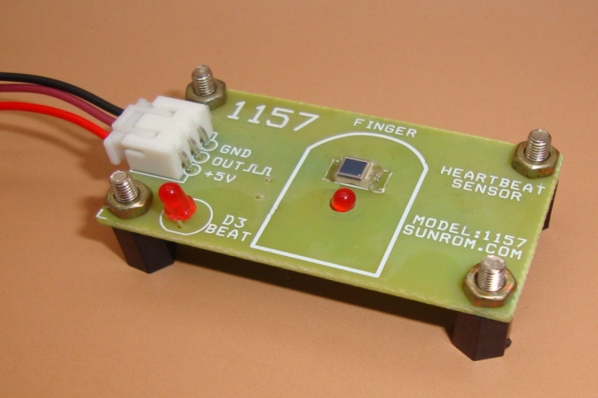

**Fig3.2 heart beat sensor**

**3.3 OLED Display**

0.96 inch OLED Display Module is a precise small, White OLED module which can be interfaced with any microcontroller using SPI protocol. It is having a resolution of 128x64. The package includes display board, display, 6 pin male header.

OLED (Organic Light-Emitting Diode) is a self light-emitting technology composed of a thin, multi-layered organic film placed between an anode and cathode. In contrast to LCD technology, OLED does not require a backlight. OLED possesses high application potential for virtually all types of displays and is regarded as the ultimate technology for the next generation of flat-panel displays.

OLEDs basic structure consists of organic materials positioned between the cathode and the anode, which is composed of electric conductive transparent Indium Tin Oxide (ITO). The organic materials compose a multi-layered thin film, which includes the Hole Transporting Layer (HTL), Emission Layer (EML) and the Electron Transporting Layer (ETL). By applying the appropriate electric voltage, holes and electrons are injected into the EML from the anode and the cathode, respectively. The holes and electrons combine inside the EML to form excitons, after which electro luminescence occurs. The transfer material, emission layer material and choice of electrode are the key factors that determine the quality of OLED components.

It can be used with either an SPI interface - selectable by soldering two jumpers on the again. The design is completely 5v-geared up, with an onboard regulator and constructed in raise converter. It's easier than ever to connect immediately for your 3v or 5v microcontroller without having any type of stage shifter.

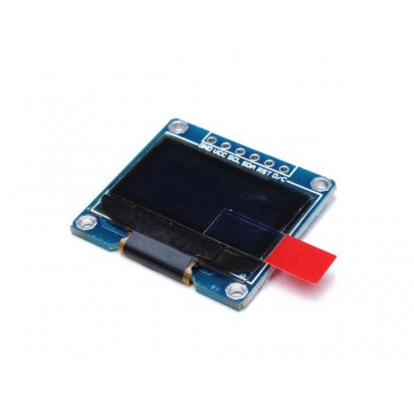

**Fig3.3:-OLED Display**

**Features:-**

* Work perfectly well without the need of back light.
* 128*64 high resolution, ultra wide viewing angle.
* Super low power consumption–only 0.08W when the whole screen lights up and 0.06W when displaying characters.
* Fully compatible with multiple controlling chips including Arduino and more.
* Support a wide range of voltage input.

**Specifications:-**

* OLED Driver IC: SSD1306.
* Resolution: 128 x 64.
* Input Voltage: 3.3V ~ 6V.
* Compatible I/O Level: 3.3V, 5V.
* Mini Size: 2.7 x 2.8cm.
* Only Need 2 I/O Port to Control.
* Working temperature: -30°C ~ 70°C.
* Module volume ( generous ): 27.0 x 27.0 x 4.1mm.
* Interface: I2C.

**3.4 RTC**

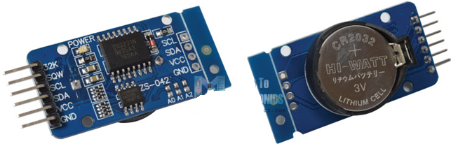

**Fig3.4:-Real Time Clocks**

The DS3231 is a low-cost, highly accurate Real Time Clock which can maintain hours, minutes and seconds, as well as, day, month and year information. Also, it has automatic compensation for leap-years and for months with fewer than 31 days.

**Features:-**

* Counts Hours, minutes and seconds.
* Day of the week, Day, Month and Year.
* Automatic compensation for leap year and for months with fewer than 31 days.
* Operating voltage from 3.3 to 5V.
* 3V Battery.
* I2C communication protocol.

The module can work on either 3.3 or 5 V which makes it suitable for many development platforms or microcontrollers. The battery input is 3V and a typical CR2032 3V battery can power the module and maintain the information for more than a year. The module uses the [I2C Communication Protocol](https://howtomechatronics.com/tutorials/arduino/how-i2c-communication-works-and-how-to-use-it-with-arduino/)which makes the connection to the Arduino Board very easy.

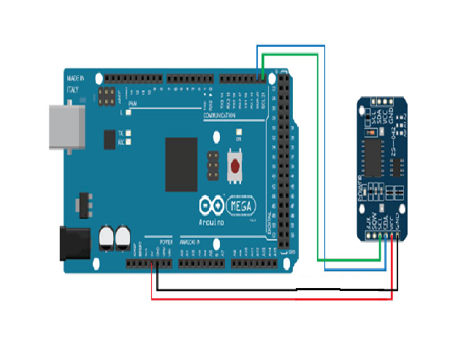

**Fig3.5:-RTC Interface with Arduino**

**There are only 4 pins: 5V, GND, SCL, SDA.**

* 5V- It is used to power to the RTC chip when you want to query it for the time. If there is no 5V signal, the chip goes to sleep using the coin cell for backup.
* GND-It connect to common power/data ground.
* SCL-Connect the SCL pin to the I2C clock SCL pin on your Arduino. On an UNO & '328 based Arduino, this is also known as A5, on a Mega it is also known as digital 21 and on a Leonardo/Micro, digital 3.
* SDA-Connect the SDA pin to the I2C data SDA pin on your Arduino. On an UNO & '328 based Arduino, this is also known as A4, on a Mega it is also known as digital 20 and on a Leonardo/Micro, digital 2.

**Specifications:**

* Highly Accurate RTC Completely Manages All Timekeeping Functions.
* Real-Time Clock Counts Seconds, Minutes, Hours, Date of the Month, Month, Day of the Week, and Year, with Leap-Year Compensation Valid Up to 2100.
* Accuracy ±2ppm from 0°C to +40°C.
* Accuracy ±3.5ppm from -40°C to +85°C.
* Digital Temp Sensor Output: ±3°C Accuracy.
* Programmable Square-Wave Output Signal.
* Simple Serial Interface Connects to Most Microcontrollers.
* Fast (400kHz) I2C Interface.
* Battery-Backup Input for Continuous Timekeeping.
* Low Power Operation Extends Battery-Backup Run Time.
* 3.3V Operating voltage.

**3.5 7805 Voltage Regulator IC:-**

Voltage sources in a circuit may have fluctuations resulting in not providing fixed voltage outputs. A voltage regulator IC maintains the output voltage at a constant value. 7805 IC, a member of 78xx series of fixed linear voltage regulators used to maintain such fluctuations, is a popular voltage regulator integrated circuit (IC). The xx in 78xx indicates the output voltage it provides. 7805 IC provides +5 volts regulated power supply with provisions to add a heat sink.

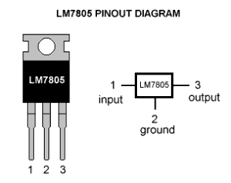

**Fig.3.6:- LM PINOUT Diagram**

**7805 IC Rating:-**

* Input voltage range 7V- 35V.
* Current rating Ic =1A.
* Output voltage range   V Max=5.2V , V Min=4.8volt.

**Pin Details of 7805 IC:-**

|  |  |  |  |
| --- | --- | --- | --- |
| **Pin No.** | **Pin** | **Function** | **Description** |
| 1 | INPUT | Input voltage (7V-35V) | In this pin of the IC positive unregulated voltage is given in regulation. |
| 2 | GROUND | Ground (0V) | In this pin where the ground is given. This pin is neutral for equally the input and output. |
| 3 | OUTPUT | Regulated output; 5V (4.8V-5.2V) | The output of the regulated 5V volt is taken out at this pin of the IC regulator. |

**Table.3.4:- Pin Details of 7805 IC**

As you may have noticed, there is a significant difference between the input voltage & the output voltage of the voltage regulator. This difference between the input and output voltage is released as heat. The greater the difference between the input and output voltage, more the heat generated. If the regulator does not have a heat sink to dissipate this heat, it can get destroyed and malfunction. Hence, it is advisable to limit the voltage to a maximum of 2-3 volts above the output voltage. So, we now have 2 options. Either design your circuit so that the input voltage going into the regulator is limited to 2-3 volts above the output regulated voltage or place an appropriate heat sink that can efficiently dissipate heat.

**What to do with all the heat?**

7805 is not very efficient and has drop-out voltage problems. A lot of energy is wasted in the form of heat. If you are going to be using a heatsink, better calculate the heatsink size properly. The below formula should help in determining appropriate heatsink size for such applications.

Heat generated = (input voltage – 5) x output current

If we have a system with input 15 volts and output current required is .5 amperes, we have:  
(15 – 5) x 0.5 = 10×0.5 =5W;

5W energy is being wasted as heat, hence an appropriate HYPERLINK "https://electronicsforu.com/electronics-projects/electronics-design-guides/low-thermal-dissipation-high-efficiency"heat sink is required to disperse this heat. On the other hand, energy actually being used is:

(5 x 0.5Amp) = 2.5W.

So twice the energy, that is actually utilized is wasted. On the other hand, if 9V is given as input at the same amount of load:

(9-5) x 0.5 = 2W

2W energy will be wasted as heat.

**What we learn: Higher the input voltage, less efficient your 7805 will be.**

An estimated efficient input voltage would be at about 7.5V.

**Other circuit components?**

If your voltage regulator is situated more than 25cm (10 inches) from the power supply, capacitors are needed to filter residual AC noise. Voltage regulators work efficiently on clean DC signal being fed. The bypass capacitors help reduce AC ripple. Essentially, they short AC noise from the voltage signal and allow only DC voltage into the regulator. The two capacitors are not necessarily required and can be omitted if you are not concerned about line noise.

However, for a mobile phone charger or logic assessment, you require a nice clean DC line. Capacitors will be beneficial in this case as they are good at maximizing voltage regulation. The values of capacitors can also be changed slightly.

Let’s take a look at what makes the IC tick.

**Schematic of 7805 IC:-**

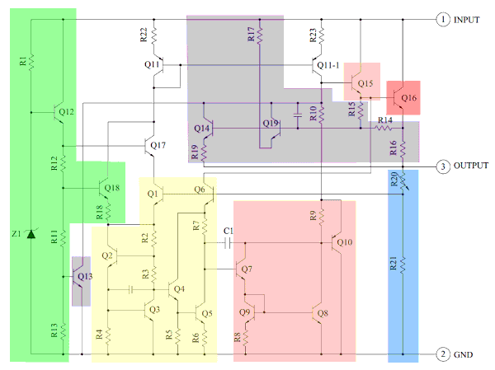

**Fig.3.7:-circuit diagram of 7805 IC**

The heart of the 7805 IC is a transistor (Q16) that controls the current between the input and output and thus controlling the output voltage. The bandgap reference (yellow) keeps the voltage stable. It takes the scaled output voltage as input (Q1 and Q6) and provides an error signal (to Q7) for indication if the voltage is too high or low. The key task of the bandgap is to provide a stable and accurate reference, even as the chip’s temperature changes.

The error signal from the bandgap reference is amplified by the error amplifier (orange). This amplified signal controls the output transistor through Q15. This closes the negative feedback loop controlling the output voltage. The startup circuit (green) provides initial current to the bandgap circuit, so it doesn’t get stuck in an “off” state. The circuit in purple provides protection against overheating (Q13), excessive input voltage (Q19) and excessive output current (Q14). These circuits reduce the output current or shutdown the regulator, protecting it from damage in case of a fault. The voltage divider (blue) scales down the voltage on the output pin for use by the bandgap reference.

**Scaling the output**

The 7805’s scaled output provides the input voltage (Vin) to the bandgap reference and the bandgap provides an error signal as the output. The 7805’s bandgap circuit removes the feedback loop that exists inside a traditional bandgap reference. Instead, the entire chip becomes the feedback loop.

If the output voltage is correct (5V), then the voltage divider provides 3.75V at Vin. Any change in output voltage propagates through Q6 and R7, causing the voltage at the base of Q7 to rise or fall accordingly. This change is amplified by Q7 and Q8, generating the error output. The error output, in turn, decreases or increases the current through the output transistor. The negative feedback loop adjusts the output voltage until it is correct.

**Application areas for 7805 IC:-**

7805 IC is used in a wide range of circuits. The major ones being:

* Fixed-Output Regulator.
* Positive Regulator in Negative Configuration.
* Adjustable Output Regulator.
* Current Regulator.
* Adjustable DC Voltage Regulator.
* Regulated Dual-Supply.
* Output Polarity-Reversal-Protection Circuit.
* Reverse bias projection Circuit.

7805 IC also finds usage in building circuits for inductance meter, phone charger, portable CD player, infrared remote control extension and UPS power supply circuits.

**3.6 4700 uF/50V Electrolytic Capacitor**

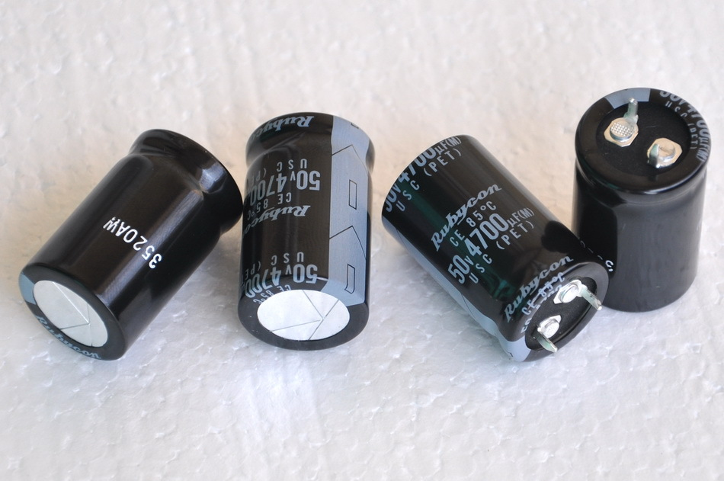

**Fig3.8:- 4700 uF/50V Electrolytic Capacitor**

**Features of 4700uF/50V Electrolytic Capacitor:**

* Type: Electrolytic.
* Operating Voltage: 50V.
* Capacitance: 4700 uf.
* Dielectric Material: sodium borate in aqueous solution.

**Applications of 4700uF/50V Electrolytic Capacitor:**

* Noise Filtration.
* As a coupling capacitor.

**3.7 GSM MODULE SIM800:-**

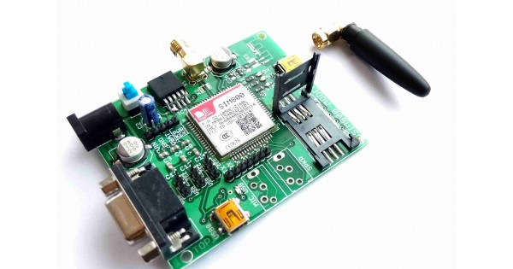

**Fig3.9:- GSM Module SIM800**

**Features**

1. GPRS multi-slot class 12/10.
2. GPRS mobile station class B.
3. Compliant to GSM phase 2/2+.
4. Dimensions: 24*24*3mm.
5. Weight: 3.14g.
6. Control via AT commands.
7. Supply voltage range 3.4 ~ 4.4V.

**CHAPTER 5**

**IMPLEMENTATION**

**5.1 BLOCK DIAGRAM OF WATCH SECTION**

OLED DISPLAY

REAL TIME CLOCK

HEART BEAT SENSOR

Bluetooth Transmitter

Mini arduino

**Fig.3.10:-Block Diagram of watch section**

**WORKING**:-

Smart Watch for Women is specially designed for women safety. The smart watch consists Heat beat sensor, Real time clock, OLED display, Bluetooth transmitter, Mini arduino and Bluetooth transmitter. The working of the watch is when the 5 volt supply is given the device(watch) will turn on. The heart beat sensor and real time clock is mounted on a watch and it interface with the mini arduino.GPS and GSM connected to ATMEGA also start working and it displays the current position of device. Then with the help of GPS the location (latitude and longitude) of the victim is detected and is displayed on the OLED Display. When the victim feels danger, she presses the first emergency key, the kit displays emergency situation and the heart beat sensors increased the heart beat it sent the message with the help of GPS and GSM message sent to a preset contact and recever section is to be is enabled.

**5.2 BLOCK DIAGRAM OF POCKET DEVICE**

BLUETOOTH RECEIVER

GPS

ARDUINO

ATMEGA

328

GSM

**Fig.3.11:-Block Diagram of Pocket Device**

**WORKING**

The figure shows the Block diagram of pocket size device. This block diagram consists of GSM (Global System Mobile Communication) and GPS (Global Position System), Bluetooth Receiver, Buzzer and Aurduino at Mega 328. The project mainly consists of the set of hardware as shown above. Basically it will be a compact device which can be used like a pocket device by girls. As and when she does the thing, a container having the chili powder will be sprayed on to the face of the culprit and simultaneously a pre recorded message will be sent(via GSM) to the near police control room and preset contact regarding the situation along with the location (via GPS) of the place where she is facing the problem. A longer buzzer will be switched on So that the surrounding people can get the attention of that and come for help. The police soon after getting the message and area location can get the help for the Girl quickly. The working of the device is when the 5 volt supply is given the device will turn on. The Bluetooth receive the data. GPS activate to track location and GSM to sent the emergency message in any three contact.

**CHAPTER 6**

**SOFTWARE USED**

**Setting Up Your Arduino:**

Before starting any project, you need to get your Arduino talking to your computer. This allows you to write and compile code for the Arduino to execute, as well as providing a way for your Arduino to work alongside your computer.

Head over to the [Arduino website](http://arduino.cc/en/Main/Software) and download a version of the Arduino software suitable for your version of Windows. Once downloaded, follow the instructions to install the Arduino **Integrated Development Environment** (IDE).

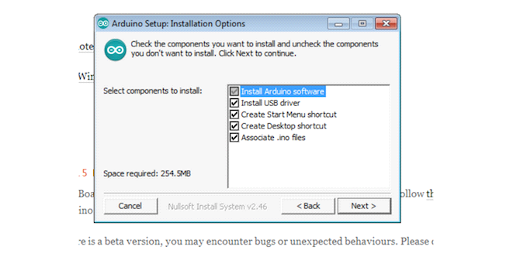The install includes drivers, so in theory, you should be good to go straight away. If that fails for some reason, try these steps to install the drivers manually:

* Plug in your board and wait for Windows to begin its driver installation process. After a few moments, the process will fail, despite its best efforts.
* Click on **Start Menu** > **Control Panel**.
* Navigate to **System and Security** > **System**. Once the System window is up, open the **Device Manager**.
* Under **Ports** (COM & LPT), you should see an open port named **Arduino UNO (COMxx)**.
* Right click on **Arduino UNO (COMxx)** > **Update Driver Software**.
* Choose **Browse my computer for Driver software**.

Navigate to and select the Uno’s driver file, named **ArduinoUNO.inf**, located in the **Drivers** folder of the Arduino Software download.

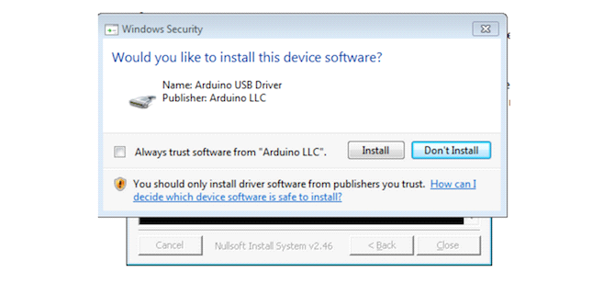

Windows will finish up the driver installation from there.

**Running the Arduino Software**

Now that the software is your Arduino is set up, let’s verify everything is working. The easiest way to do this is by using the “Blink” sample application.

Open the Arduino Software by Double-clicking the Arduino Application (**./arduino on Linux**). Make sure the board is connected to your computer, and then open the **LED blink** example sketch: **File** > **Examples** > **1.Basics** > **Blink**. You should see the code for the application .

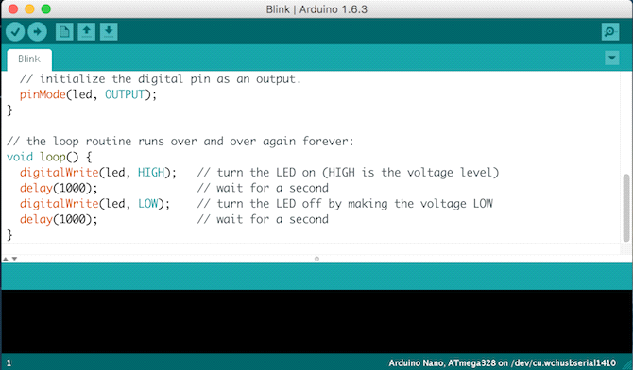

In order to upload this code to your Arduino, select the entry in the **Tools** > **Board** menu that corresponds to your model — **Arduino Uno** in this case.

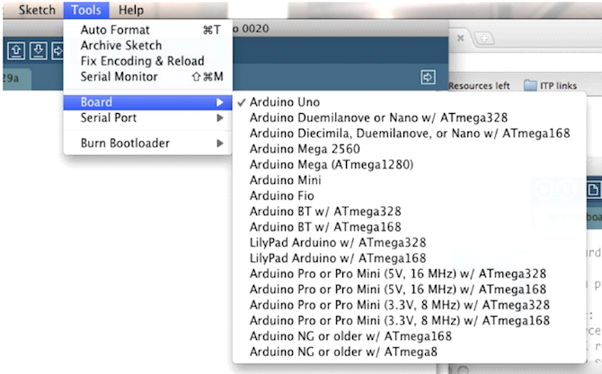

Select the serial device of your board from the **Tools** > **Serial Port** menu. On Windows, This is likely to be **COM3** or higher. On Mac or Linux this should be something with **/dev/tty.usbmodem** in it.

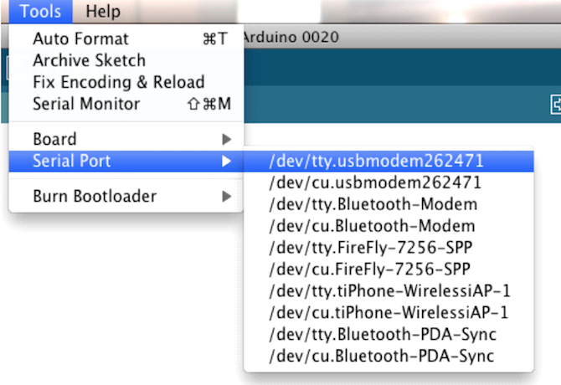

Finally, click the **Upload** button on the top left of your environment. Wait a few seconds, and you should see the **RX** and **TX** LEDs on the Arduino flashing. If the upload is successful, the message “Done uploading” will appear in the status bar.

A few seconds after the upload finishes, you should see the **pin 13** LED on the board start to blink. Congratulations! You’ve got your Arduino up and running.

**CHAPTER 7**

**FLOWCHART**

Initialize port

Read BPM

Initialize UART at 9600

Read RTC

Send data to pocket Device

Read GPS

Shown on OLED Display

IF Switch =1

HB>110

Send message to preset contact

**No**

**yes**

**CHAPTER 8**

**ADVANTAGES AND DISADVANTAGES**

**8.1 ADVANTAGES**

* Can be used as a legal evidence of prime with exact location information for prosecution.
* Health tracker- For health –conscious people, it lets you count your daily steps, tracks your heart beat rate.
* Alert message to mobile phone for remote information.
* Mobile number can be changed at any time.
* Can be used to prevent incidents.
* Can be used for the safety of woman.
* Wireless connectivity.
* Environmental friendly system.

**8.2 DISADVANTAGES**

* There is no hidden camera detector which is portable to ensure our privacy.
* Battery life- Some smart watches last upto 1-2 days but some might not even go on for a day.
* Network Problem.

**CHAPTER 9**

**FUTURE SCOPE**

As the technological changes or new requirement from user to enhance the functionality of product may requires new version to introduce. Although the System is complete and working efficiently, new modules which enhance the system functionality can be added without any major changes to the entire system. By keeping this ability of the product 1 mind, an incremental process model has been used to design and develop the system. These are as follows

* Primary School Children Safety: As the school children safety are major concerns for parents as well as school management due to the recent incidents of child crimes like children missing, abuse etc. This module monitors the child safety when they are travelling in school buses. Once they reached the school the device gets deactivated by school authority and message send the parents that, ―the child reaches the school safely‖. At return journey again the device is activated by school authority and when they reached the home, the acknowledge message is send to the school when parents deactivate the device. The device is capable of audio recording when activated that can be listening by the parents or authorize person.
* Mobile and other valuables Safety System Module: The missing rate of mobiles is high while travelling from bus, train or crowed public area. The area zone module functionality further enhances to provide safety. A small device needed to keep either in same pocket or within the range of few centimeters. As you kept the mobile and forget to pick up or someone stolen it then to small range the siren of mobile as well as device gets ON for user attention. Also the same device can attach to our luggage, hence in case of forgetting to pick back or try to stolen by someone can be easily noticed by the module and make the attention of user through the siren alarm. Hence, the advance technology makes the system more robust and reliable. As the new modules provide the functionality which enhance the safety and security. Thus it helps to fulfill the purpose of the project.

**CHAPTER 10**

**APPLICATION**

* It can be used as an inexpensive alternative to Smart Watches and other expensive Heart Rate Monitors.
* Safety of women.
* Used as a legal evidence of crime with exact location information for prosecution.
* Provide parents with a sense of security for their child in today's time.
* Can be used for the safety of physically challenged & elderly aged people.
* Used for tracking soldiers.
* Ensures child safety.

**CHAPTER 11**

**CONCLUSION**

A low cost and a high security system for the women’s using the GPS, GSM and Heart beat sensors have been designed. The Heart beat sensors are mainly used for sensing the vital sign parameters such as heart beat. The message can be sent over long distance via GSM in case of emergency or injury. The GPS tracks the location of the person. Hence a wearable technology with high security for women is implemented and designed.

**REFERENCES**

[1] D. G. Monisha, M. Monisha, G. Pavithra, and R. Subhashini," Women Safety Device and Application-FEMME". Vol 9(10), Issue March 2016 .

[2] Dr. Sridhar Mandapati, Sravya Pamidi, Sriharitha Ambati," A Mobile-based Women Safety Application (I Safe App)". Vol 17, Issue 1, Ver. I (Jan – Feb. 2015) .

[3] Deepak Sharma, Abhijit Paradkar “All in one Intelligent Safety System for Women Security”. Vol 130 No.11 November 2015.

[4] Prof. R.A. Jain, Aditya Patil, Prasenjeet Nikam, Shubham More, Saurabh Totewar,” Women’s safety using IOT “. Vol: 04 Issue: 05 May-2017.

[5] Swapnil N. Gadhave, Saloni D. Kale, Sonali N. Shinde (2017)” Electronic Jacket for Women Safety”. Volume 04 Issue 05 May 2017.

[6] Daniel Clement, Kush Trivedi, Saloni Agarwal, Shikha Singh (2016) "AVR Microcontroller Based Wearable Jacket for Women Safety." Vol: 03 Issue: 05 May-2016.

[7] Prof. Basavaraj Chougula1, Archana Naik Monika Monu, Priya Patil and Priyanka Das “SMART GIRLS SECURITY SYSTEM “Vol 3, Issue 4, April 2014.

[8] Akanksha Chandoskar, Shraddha Chavan, Yojana Mokal, Payal Jha, Pournima Kadam,” Smart Gadget for Women’s safety”. Vol: 4 Issue: 1 Jan 2016 .

[9] ]en.wikipedia.org/wiki/radio_frequency_identification.

[10] http://timesofindia.indiatimes.com/topic/mobile-apps-for-women's-safety.

[11] www.darkreading.com/perimeter/new_onoff_switch_protects_rfid_cards_fr o/211201220.